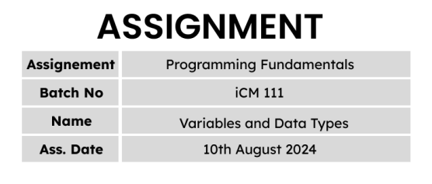

Q 01

class Example{

public static void main(String args[]){

System.out.println("Ishini Udayangana");

}

}

//////////////////////////////// OUTPUT //////////////////////////////////////

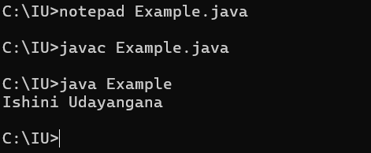

Q 02

class Example{

public static void main(String args[]){

System.out.println("Ishini Udayangana");

System.out.println("no.158, Dalada Watte rd, Wadduwa.");

System.out.println("0775766995");

System.out.println("ishiniudayangana@gamail.com");

}

}

//////////////////////////////// OUTPUT //////////////////////////////////////

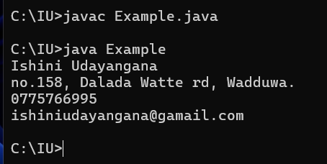

Q 03

class Example{

public static void main(String args[]){

System.out.println("*");

System.out.println("* *");

System.out.println("* * *");

System.out.println("* * * *");

}

}

//////////////////////////////// OUTPUT //////////////////////////////////////

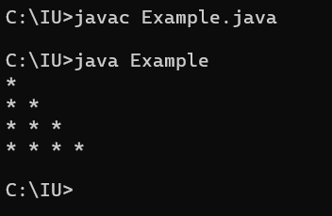

Q 04

class Example{

public static void main(String args[]){

System.out.println(" 299");

System.out.println("+ 800");

System.out.println("-------------------");

System.out.println(" 1099");

System.out.println("===================");

}

}

//////////////////////////////// OUTPUT //////////////////////////////////////

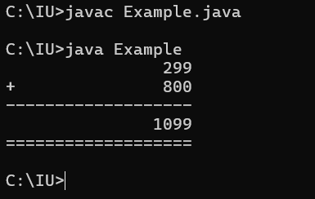

Q 05

class Example{

public static void main(String args[]){

System.out.println("* * * * * * =======================================");

System.out.println(" * * * * * =======================================");

System.out.println("* * * * * * =======================================");

System.out.println(" * * * * * =======================================");

System.out.println("* * * * * * =======================================");

System.out.println(" * * * * * =======================================");

System.out.println("* * * * * * =======================================");

System.out.println(" * * * * * =======================================");

System.out.println("* * * * * * =======================================");

System.out.println("===================================================");

System.out.println("===================================================");

System.out.println("===================================================");

System.out.println("===================================================");

System.out.println("===================================================");

System.out.println("===================================================");

}

}

//////////////////////////////// OUTPUT //////////////////////////////////////

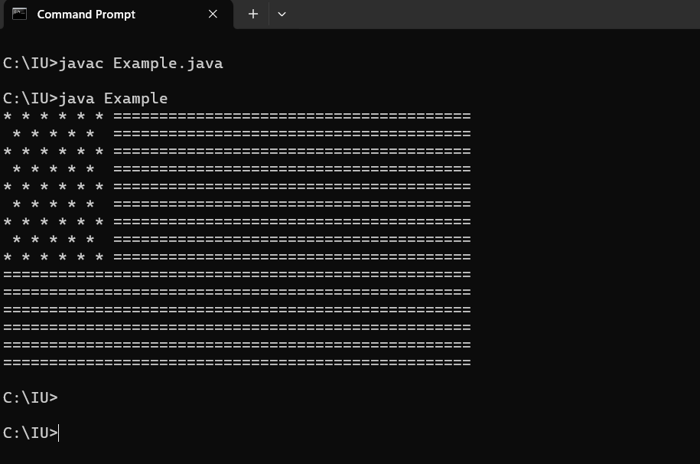

Q 06

//////////////////////////////// OUTPUT //////////////////////////////////////

program A

Institute of Computer Engineering Technology

223 A,

Galle Road,

Panadura.

program B

Institute of Computer Engineering Technology

223 A,Galle Road,Panadura.

Q 07

When we use print function, printed the syntax that given in parentheses and the curser goes to end of the syntax.

When we use println function, printed the syntax that given in parentheses and the curser goes to next line of the syntax.

System.out.print(1)

System.out.println(2)

System.out.println(3)

Q 08

In line 1 printed the string “a” and line 2 printed the character ‘a’.

Q 09

line 1 = Integer value

line 2 = floating point value

line 3 = String

line 4 = character

Q 10

int = Integer values

Eg: 12, 785, -45

float = Floating point values

Eg: 10.0, 12.123, -456.32

char = Character literals(representing by a one character in single quotation)

Eg: ‘A’, ‘7’, ‘#’

string = Strings(Can representing anything as string in double quotation)

Eg: “abc”, “1235”, “A”

boolean = true, false

Q 11

Line1 – 1100100 – It is an integer value

Line2 – 100 – There is 0B. So, It would be a binary value.(64+32+4 = 100)

Line3 – 01100100 – It is an integer value

Line4 – 17826048 – There is 0x. It’s mean, that is hexadecimal value(256+1048576+16777216 = 17826048)

Q 12

Line1 - There is 0B. So, It would be a binary value(4+32+64+128 = )

Line2 - There is 0b. So, It would be a binary value

Q 13

A

BCD

EF

G

H

Q 14

1. class Example{

public static void main(String args[]){

System.out.print("iCM-iCET CERTIFIED MASTER");

}

}

//////////////////////////////// OUTPUT //////////////////////////////////////

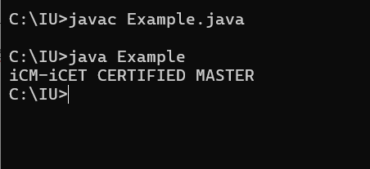

1. class Example{

public static void main(String args[]){

System.out.print("iCM\n\niCET\nCERTIFIED\nMASTER");

}

}

//////////////////////////////// OUTPUT //////////////////////////////////////

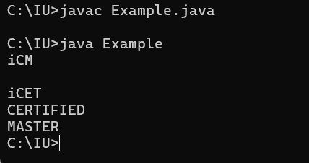

1. class Example{

public static void main(String args[]){

System.out.print("iCM\n\niCET CERTIFIED MASTER");

}

}

//////////////////////////////// OUTPUT //////////////////////////////////////

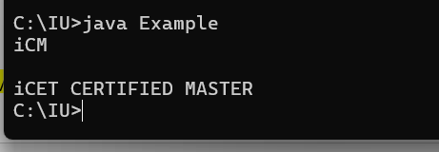

Q 15

Hello

JAVA

Hello JAVA

Hell JAVA

\Hello JAVA\

“Hello

JAVA”

‘Hello

JAVA’

Escape Sequences = \n(To move to next line), \t(To print Tab), \b(backspace), \\(To, \”(To print the double quotation in string without error), \’(To print single quotation in character literals without error)

Q 16

class Example{

public static void main(String args[]){

System.out.println("a.java is a typed language"); System.out.println("AB\"CB");

System.out.println("AB\\CD");

System.out.println("C:\\Windows\\Program");

System.out.println("AB\\\"CD");

System.out.println("AB\\\\\"\"CD");

System.out.println("AB\\nCD");

System.out.println("AB\\tCD");

System.out.println("AB\\bCD");

}

}

//////////////////////////////// OUTPUT //////////////////////////////////////

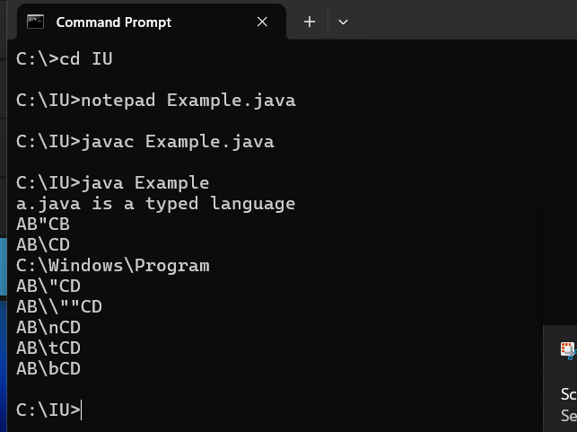

Q 17

class Example{

public static void main(String args[]){

System.out.println(" _ ________ ________ _________");

System.out.println(" (_)/ _______| ______|___ ___| ");

System.out.println(" _| | | |____ | |");

System.out.println(" | | | | ____| | |");

System.out.println(" | | |_______| |______ | |");

System.out.println(" |_|\\________|________| |_| ");

}

}

//////////////////////////////// OUTPUT //////////////////////////////////////

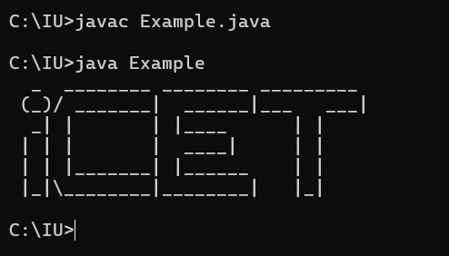

Q 18

class Example{

public static void main(String args[]){

System.out.println(" X ");

System.out.println(" / \\");

System.out.println(" / \\");

System.out.println(" / \\");

System.out.println(" / \\");

System.out.println(" / \\");

System.out.println(" / \\");

System.out.println(" '''''''''''''''");

System.out.println(" ___|_|___");

}

}

//////////////////////////////// OUTPUT //////////////////////////////////////

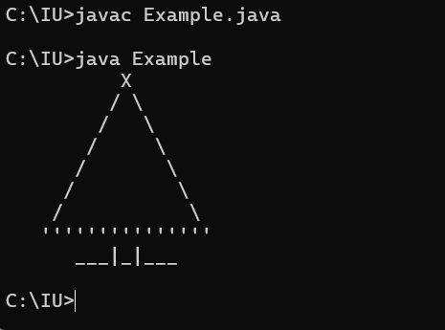

Q 19

class Example{

public static void main(String args[]){

System.out.println(" +\"\"\"\"\"+");

System.out.println(" [| o o |] ");

System.out.println(" | ^ |");

System.out.println(" | '-' |");

System.out.println(" +'''''+");

System.out.println(" |||||||||");

System.out.println(" /\\/\\/|||||||||||\\/\\/\\");

System.out.println(" |||||||||||||");

System.out.println(" |||||||||||||||");

System.out.println(" |||||||||||||");

System.out.println(" |||||||||||");

System.out.println(" |||||||||");

System.out.println(" /\\ /\\");

}

}

//////////////////////////////// OUTPUT //////////////////////////////////////

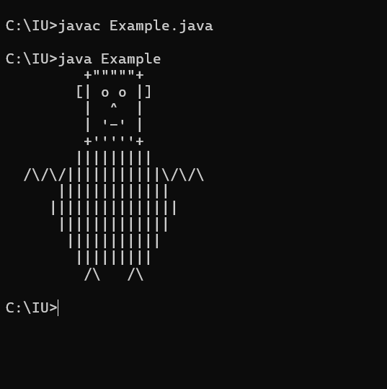

Q 20

line 1 – Initialize the value is an integer value

line 2 – Assign the variable value

line 3 – print the variable

Q 21

class Example{

public static void main(String args[]){

int x, y ;

x = 102;

y = 103;

System.out.println(x+" "+y);

System.out.println(y+" "+x);

}

}

//////////////////////////////// OUTPUT //////////////////////////////////////

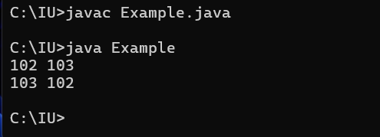

Q 22

1. Runtime error

Q 23

//////////////////////////////// OUTPUT /////////////////////////////////////

10

20

30

200

Q 24

//////////////////////////////// OUTPUT //////////////////////////////////////

100

200

100

300

X and y are variables. So, when we call to the variable, the variable value will assign to it.

After the variable y value is changed. Then the y variable value is 300.

Q 25

B

Initialized x is an integer value. We have to print the x variable. So we should assign the valiable value. Because of that the answer is B.

Q 26

C

Q 27

//////////////////////////////// OUTPUT //////////////////////////////////////

Line1 – 1020

Line 2 – 30

Line 1 is string and line 2 is integer values

Q 28

60

10+20+30

10+2030

10+2030

102030

3030

102030

Q 29

A.6

B.123

C.150

D.1 2 3

E.198

F. ABC

G.365

H.A B C

Q 30

In this case we get a input from user to “i”. In the question 20 we assign a value to “i”.

Q 31

import java.util.*;

class Example{

public static void main(String args[]){

Scanner input = new Scanner(System.in);

int num1, num2, total;

num1 = input.nextInt();

num2 = input.nextInt();

System.out.println("First number - "+num1);

System.out.println("First number - "+num2);

total = num1+num2;

System.out.println(num1 + " "+num2 + " = " + total);

}

}

//////////////////////////////// OUTPUT //////////////////////////////////////

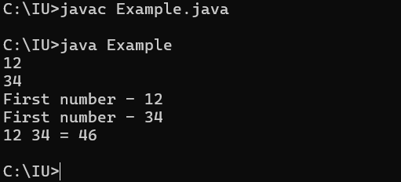

Q 32

import java.util.*;

class Example{

public static void main(String args[]){

Scanner input = new Scanner(System.in);

int n;

n = input.nextInt();

System.out.println("Input number: "+n);

System.out.print(n);

System.out.print(n);

System.out.println(n);

System.out.println(n+n+n);

}

}

//////////////////////////////// OUTPUT //////////////////////////////////////

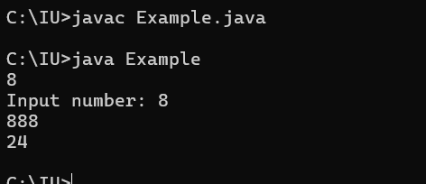

Q 33

import java.util.*;

class Example{

public static void main(String args[]){

Scanner input = new Scanner(System.in);

int com, chem, phy, eng, total;

com = input.nextInt();

chem = input.nextInt();

phy = input.nextInt();

eng = input.nextInt();

total = com + chem + phy + eng;

System.out.println("Combined Maths - "+com);

System.out.println("Chemestry - "+chem);

System.out.println("Physics - "+phy);

System.out.println("English - "+eng);

System.out.println("Total - "+total);

}

}

//////////////////////////////// OUTPUT //////////////////////////////////////

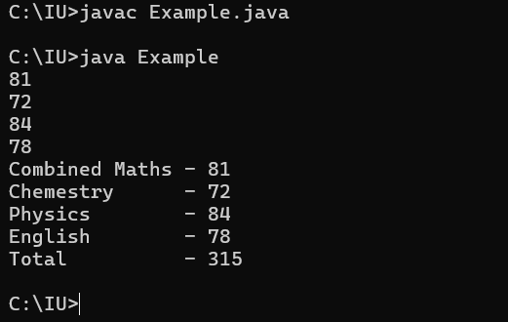

Q 34

//////////////////////////////// OUTPUT //////////////////////////////////////

Q 35

//////////////////////////////// OUTPUT //////////////////////////////////////

Q 36

//////////////////////////////// OUTPUT //////////////////////////////////////

Q 37

//////////////////////////////// OUTPUT //////////////////////////////////////

Q 38

My Variable

@name

$percent

123num

Java.org

Q 39

32767

-32768

Q 40

//////////////////////////////// OUTPUT //////////////////////////////////////

A

66

A1

a

98

a1

Q 41

1. 6
2. 54
3. 54
4. 150
5. 54
6. Error occurred
7. Error occurred
8. 198
9. 150

Q 42

//////////////////////////////// OUTPUT //////////////////////////////////////

Q 43

//////////////////////////////// OUTPUT //////////////////////////////////////

Q 44

//////////////////////////////// OUTPUT //////////////////////////////////////

Q 45

Line1 – This one is a string. Because the value is in double quotation marks

Line2 – At the above line, there is variable named “s”. So, when we called the variable the variable’s value is assign to it.

Q 46

import java.util.*;

class Example{

public static void main(String[] args) {

Scanner input = new Scanner(System.in);

System.out.print("Enter you name : ");

String name = input.nextLine();

System.out.println("Hello " + name + " nice to meet you!");

}

}

//////////////////////////////// OUTPUT //////////////////////////////////////

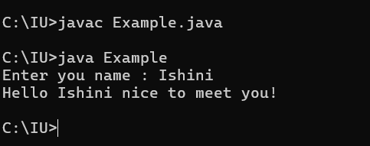

Q 47

//////////////////////////////// OUTPUT //////////////////////////////////////

131y105z

Q 48

//////////////////////////////// OUTPUT //////////////////////////////////////

Q 49

//////////////////////////////// OUTPUT //////////////////////////////////////

Q 50

//////////////////////////////// OUTPUT //////////////////////////////////////

import java.util.*;

class Example{

public static void main(String args[]){

int mark1, mark2, mark3, total;

string sub1, sub2, sub3;

Scanner input = new Scanner(System.in);

System.out.println("----Subject total calculator----");

System.out.print("Subject 1 name - ");

String sub1 = input.nextLine();

System.out.printf("%s marks - ", sub1);

mark1 = input.nextInt();

System.out.print("Subject 2 name - ");

String sub2 = input.nextLine();

System.out.printf("%s marks - ",sub2);

mark2 = input.nextInt();

System.out.print("Subject 3 name - ");

String sub3 = input.nextLine();

System.out.printf("%s marks - ",sub3);

mark3 = input.nextInt();

System.out.printf("\n\n%s %d\n%s %d\n%s %d\n",sub1,mark1,sub2,mark2,sub3,mark3);

total = mark1+mark2+mark3;

System.out.printf("Total %d",total);

}

}

import java.util.*;

class Example{

public static void main(String[] args) {

Scanner input = new Scanner(System.in);

int age;

System.out.print("Enter your friend's name : ");

String name = input.nextLine();

System.out.print("Enter you friends age : ");

age = input.nextInt();

System.out.print("Enter your friend's living place : ");

String place = input.nextLine();

System.out.printf("%s is my best friend. He is %d years old and lives in the beatiful town of %s", name ,age, place);

}

}